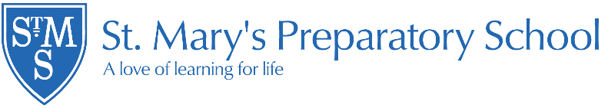

Leavers 2025

Destination | Pupils
Abingdon School | 1
Gillotts School | 1
Icknield Community College | 1
Leighton Park School | 3
Millfield | 2
Pangbourne College | 2
Queen Anne’s School | 1
Reading Bluecoats School | 2
Royal Grammar School | 1
St Helen’s and St Katharine’s | 2
Pangboune College | 2

Total leavers: 18

In 2025, of those Year 6 pupils who sat entrance exams for Independent Schools, 100% were successful in securing places at their chosen schools.

We are delighted with the outstanding success of all our children who chose to sit the 11+ examinations, and we congratulate our pupil who will be taking up a place at Royal Grammar School in High Wycombe.

This year’s Year 6 children were offered places at schools including the following:

Abingdon School
Headington School
Leighton Park
Millfield
Our Lady’s Abingdon
Pangbourne College
Queen Anne’s School
Reading Bluecoat School
St. Joseph’s College
St. Helen’s and St. Katharine’s School
Royal Grammar Schol, High Wycombe
Gillotts School
Icknield

Scholarships and Awards:

- Art Scholarship
- Three Academic Scholarships
- Sport Scholarship
- Griffin Award, Abingdon School
- Drama Scholarship

